BOOGEYMAN 3



Mobius
Follow
13 min read
·
Aug 2, 2025
5

Open the image to view it in full size
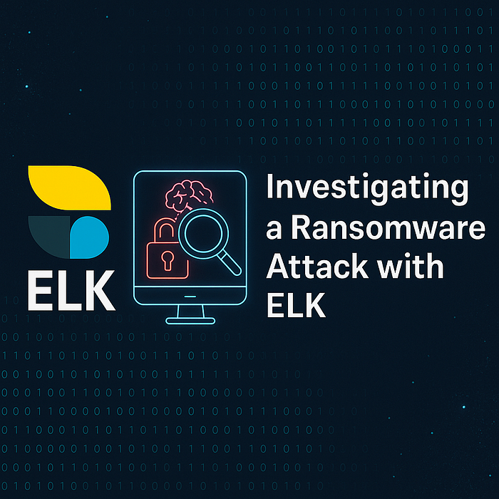
📝Scenario Overview
The Quick Logistics LLC corporate environment experienced a stealth-concentrated cyberattack that slipped past the initial defenses. Suspicious user activity triggered alerts pointing to potential network traversal and credential extraction. As a security analyst, your task is to investigate how the threat actor maintained persistent access, escalated privileges using UAC bypass, extracted credentials via Mimikatz, and eventually aimed at the domain controller with a DCSync attack. Using ELK stack and Sysmon log entries, this incident response journey reveals every stage of compromise — from the first payload to the final ransomware deployment.
🧩Overview of the Challenge
The Boogeyman 3 challenge simulates a multi-stage cyberattack on Quick Logistics LLC, beginning with a phishing email sent to the CEO, Evan Hutchinson. Though Evan reported the suspicious email, the threat actor had already launched a stage-one payload hidden inside an ISO file (review.dat). The payload was copied to a stealthy location and triggered using rundll32.exe, establishing persistent access through a scheduled task named “Review.” Exploiting a UAC bypass via fodhelper.exe, the threat actor escalated privileges and utilized a GitHub-hosted Mimikatz tool to dump credentials. Armed with the credentials of a local admin (itadmin), the threat actor accessed a PowerShell script (IT_Automation.ps1) from a shared drive, revealing domain credentials (allan.smith:Tr!ckyP@ssw0rd987). These were utilized to move laterally to another host (WKSTN-1327), where further credentials were dumped, including the hash of the local administrator. The final stage saw the threat actor perform a DCSync attack from the Domain Controller, dumping the hashes of privileged accounts and completing a full domain compromise.
🩻TASK 2 The Chaos Inside
Before I dive into the analysis, I make sure to set the right time range in Kibana. The threat actor activity happened between August 29, 2023 @ 00:00:00.0 and August 30, 2023 @ 23:30:00.0, so I adjust the filter to only include log entries within this window. This reduces unnecessary noise and keeps the focus on relevant activity. Without setting this, I might miss out on key events or waste time going through irrelevant data. Filtering by time is always my first step.
Open the image to view it in full size
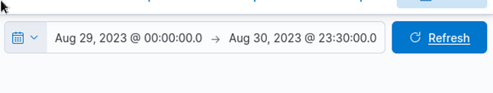
🆔1.) What is the PID of the process that launched the initial stage 1 payload?
I began by filtering event ID 1 in ELK. This event type is important because it log entries the creation of new processes, which is exactly what I need to trace the start of the attack chain.
I then concentrated on any suspicious execution of PowerShell.exe, since attackers often use PowerShell for payload delivery. While digging through the log entries, I observed that the parent process was mshta.exe, a known LOLBin🗑️often abused in attacks. Looking at the image below, I could confirm this by checking the field process.parent.name, which shows mshta.exe.
Open the image to view it in full size
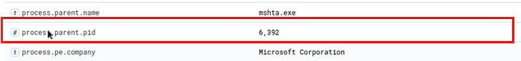
Right below that, the field process.parent.pid displays the PID as 6392, which means this is the process that launched the initial stage 1 payload. This PID helps track the threat actor's movement across the system and is critical for chaining together the rest of the behavior.
😺1st Flag: 6392
The PID of the process that launched the initial stage 1 payload is 6392, confirming that mshta.exe was the launching point of the attack chain.
👹2.) The stage 1 payload attempted to implant a file to another location. What is the full command-line value of this execution?
I first filtered for Windows-native tools that could indicate file movement especially commands like copy or xcopy. That’s when I spotted the process xcopy.exe, which caught my attention🤓.
Open the image to view it in full size
Looking deeper, I verified it was utilized to implant the payload by transferring the file from D:\review.dat to a new path. The full command-line clearly showed.
😺2nd Flag: “C:\Windows\System32\xcopy.exe” /s /i /e /h D:\review.dat C:\Users\EVAN~1.HUT\AppData\Local\Temp\review.dat
This verified that the stage 1 payload attempted to implant itself into the user’s temporary folder to maintain stealth and persistent access.
📁3.) The implanted file was eventually utilized and launched by the stage 1 payload. What is the full command-line value of this execution?
To trace the execution of the implanted file, I searched for any usage of review.dat, which was previously copied into a temporary directory. I then investigated the process tree and found that fodhelper.exe was invoked, commonly utilized in UAC bypass techniques due to its auto-elevated privileges.
Open the image to view it in full size
Upon checking the parent process details of fodhelper.exe, I observed the following parent command-line.
Open the image to view it in full size
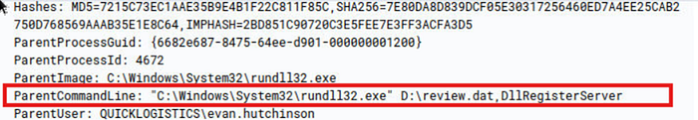
😺3rd Flag: “C:\Windows\System32\rundll32.exe” D:\review.dat,DllRegisterServer
This verified that the threat actor launched the suspicious DLL file (review.dat) using rundll32.exe, passing the DllRegisterServer export as an argument which is a way to execute DLL payloads.
💣4.) The stage 1 payload established a persistent access mechanism. What is the name of the scheduled task created by the suspicious script?
To begin my analysis, I filtered the log entries using the filename projectfinancial* and narrowed it further with winlog.event_id: 1 to only view process creation events. This assisted reduce noise and zone in on suspicious script-based executions.
Open the image to view it in full size
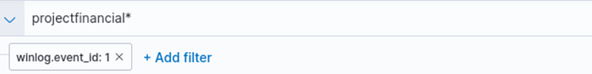
Among the log entries, I saw a PowerShell.exe execution referencing review.dat, which I initially thought was a harmless file. But on deeper inspection, I noticed it was actually being passed as an argument to rundll32.exe, which is commonly abused to load DLLs. This made it clear that review.dat was a suspicious DLL.
Open the image to view it in full size
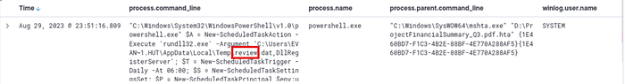
The PowerShell command utilized New-ScheduledTaskAction along with other task scheduling functions, which indicated the threat actor was trying to set up a persistent access mechanism on the system. Inside that command, I discovered the scheduled task name created by the threat actor.
😺4th Flag: Review
The threat actor established persistent access by creating a scheduled task named Review, which launched the suspicious review.dat DLL.
🤖5.) The execution of the implanted file inside the system has initiated a potential C2 network connection. What is the IP and port utilized by this network connection? (format: IP:port)
To investigate this, I already knew from earlier steps that the suspicious DLL file (disguised as review.dat) was launched using rundll32.exe. Since rundll32.exe is the process responsible for executing the payload, I concentrated on its potential network behavior.
I began by filtering for network-related log entries, specifically winlog.event_id: 3, which tracks network connections. Then, I filtered using the process name rundll32.exe* to find if any outgoing connections were established during or after its execution.
Open the image to view it in full size
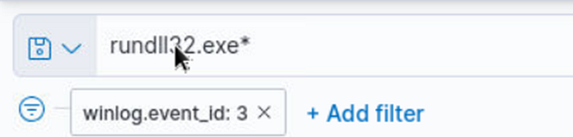
While scrolling through the log entries, I detected a log entry showing a network network connection initiated by rundll32.exe. The log displayed a network connection attempt to the IP address 165.232.170.151 over port 80.
Open the image to view it in full size
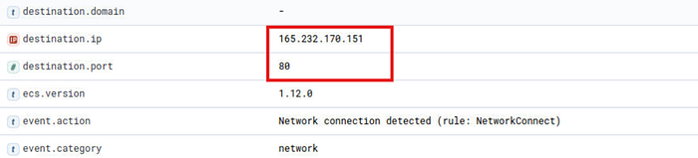
😺5th Flag: 165.232.170.151:80
The rundll32.exe payload successfully initiated a Command-and-Control (C2) network connection to 165.232.170.151 over port 80.
👤6.) The threat actor has discovered that the current access is a local administrator. What is the name of the process utilized by the threat actor to execute a UAC bypass?
I filtered for fodhelper.exe under Windows event ID 1 because this ID is commonly associated with process creations. I suspected this process might have been utilized by the threat actor for privilege escalation.
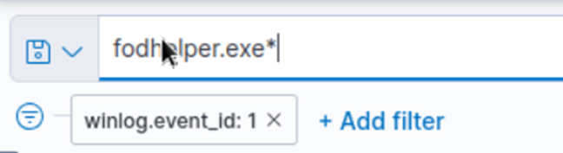
Below, I observed a record showing fodhelper.exe being utilized to run a command that executes rundll32.exe with the suspicious review.dat DLL. This verified that the threat actor utilized fodhelper.exe to bypass UAC and elevate privileges to execute the DLL file.
Open the image to view it in full size
To verify this, I searched online and verified that fodhelper.exe is a known method utilized in UAC bypass techniques. The threat actor exploited this trusted process to run suspicious commands without triggering the User Account Control prompt.
Open the image to view it in full size
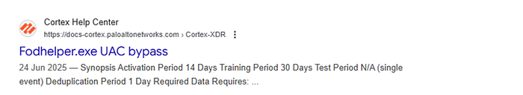
😺6th Flag: fodhelper.exe
The UAC bypass was achieved using fodhelper.exe, a legitimate Windows executable often abused for privilege escalation.
⚒️7.) Having a high privilege system access, the threat actor attempted to dump the credentials inside the system. What is the GitHub link utilized by the threat actor to retrieve a tool for credential extraction?
While researching credential extraction, I observed that Mimikatz is one of the most commonly utilized tools by attackers. This tool allows attackers to extract plaintext credentials from LSASS memory, perform pass-the-hash, and forge Kerberos tickets. Understanding This assisted narrow down what to look for when searching for evidence of credential extraction in the log entries.
Open the image to view it in full size
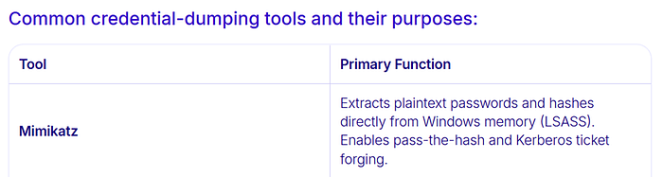
I decided to use mimikatz* as my search term to find any indication of the tool being utilized or retrieved. This allowed me to locate PowerShell activity and command-line arguments related to Mimikatz.
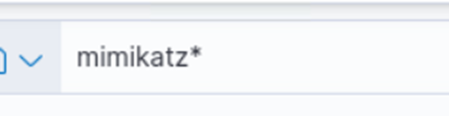
From the log, I discovered that PowerShell was utilized to fetch a ZIP file from the following URL.
Open the image to view it in full size
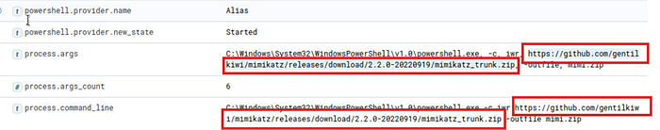
This is a clear indication that the threat actor retrieved Mimikatz from GitHub directly to the compromised system, likely to extract user credentials.
😺7th Flag: https://github.com/gentilkiwi/mimikatz/releases/retrieve/2.2.0-20220919/mimikatz_trunk.ziphttps://github.com/gentilkiwi/mimikatz/releases/download/2.2.0-20220919/mimikatz_trunk.zip
The threat actor retrieved Mimikatz via PowerShell from GitHub to perform credential extraction.
#️⃣8.) After successfully dumping the credentials inside the system, the threat actor utilized the credentials to gain access to another system. What is the username and hash of the new credential pair? (format: username:hash)
To begin investigating whether the threat actor utilized credentials from a dumped session, I utilized this filter.
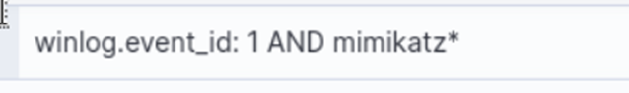
This assisted narrow down the log entries to execution events (event ID 1) involving the tool mimikatz, which is commonly utilized for credential extraction.
The filtered result shows two relevant log entries.
Open the image to view it in full size
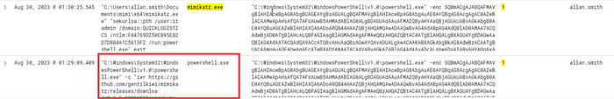
- First log (bottom): Shows a PowerShell command being utilized to retrieve mimikatz from GitHub.
- Second log (top): Occurred shortly after and shows the execution of mimikatz.exe.
Here, mimikatz.exe is highlighted again, and we can clearly see the path to the executable, as well as a suspicious execution command.
Open the image to view it in full size
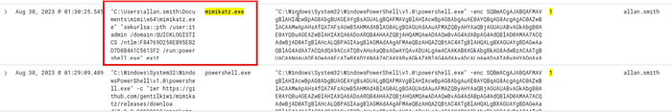
This command specifically uses pass-the-hash (pth) technique with the provided NTLM hash, targeting the itadmin user which typically a privileged account.

After that to further investigate I click into that specific query and check the message section.
Open the image to view it in full size
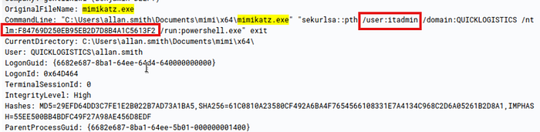
In this message section of the event log:
- The OriginalFilename confirms the tool utilized: mimikatz.exe
- The full command-line shows the user: itadmin
- The NTLM hash utilized is: F84769D250EB95EB2D7D8B4A1C5613F2
Together, this proves the threat actor utilized the dumped credential (itadmin with the provided hash) to try accessing another system.
😺8th Flag: itadmin:F84769D250EB95EB2D7D8B4A1C5613F2
By filtering for mimikatz executions and analyzing the event log entries, I detected that the threat actor utilized the credential itadmin along with a dumped NTLM hash, confirming network traversal using high-privilege credentials.
🗃️9.) Using the new credentials, the threat actor attempted to enumerate accessible file shares. What is the name of the file accessed by the threat actor from a remote share?
I began by filtering events using a simple and effective query.
Open the image to view it in full size
This assisted me narrow down any command-line activity that could point toward file enumeration using either cmd.exe or PowerShell.exe.
While going through the results, I observed a suspicious use of PowerShell.
Open the image to view it in full size
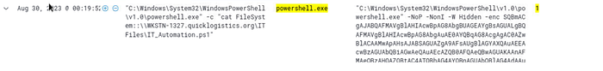
This showed that the threat actor accessed a PowerShell script file from a remote share, which immediately raised a red flag for me.
To confirm the filename, I checked the full command-line again.
Open the image to view it in full size
This proved that the threat actor utilized PowerShell to read a script directly from the ITFiles share of a remote system named WKSTN-1327.
😺9th Flag: IT_Automation.ps1
I successfully detected that the threat actor utilized their escalated access to browse shared drives and opened the file IT_Automation.ps1 from a remote system using PowerShell.
🪪10.) After getting the contents of the remote file, the threat actor utilized the new credentials to move laterally. What is the new set of credentials discovered by the threat actor? (format: username:password) ?
To determine the new credentials utilized by the threat actor during network traversal, I started by continuing my log analysis using the same filter query.
Open the image to view it in full size
While reviewing the command-line activity log entries, a specific event caught my attention because it contained the use of the $Credential variable a strong indicator that credential usage or manipulation was occurring.
Open the image to view it in full size
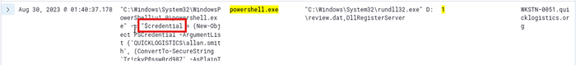
Upon inspecting this event further, I discovered a suspicious PowerShell command that constructs a PSCredential object using a hardcoded username and a secure string conversion of a plaintext password. The command was structured to impersonate a user when executing remote commands on a target system.
Open the image to view it in full size
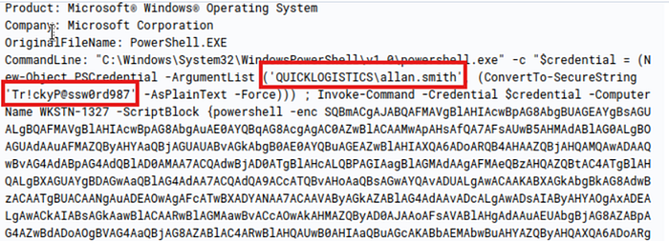
This clearly reveals that the threat actor had harvested and reused a set of credentials to initiate network traversal. The username and password pair was embedded directly in the script and utilized to remotely access the system WKSTN-1327.
😺10th Flag: QUICKLOGISTICS\allan.smith:Tr!ckyP@ssw0rd987
This confirms that allan.smith's credentials were obtained by the threat actor and leveraged to access another host within the network.
🎯11.) What is the host name of the threat actor’s target system for its network traversal attempt?
To determine the host name of the system aimed at during the threat actor’s network traversal, I continued examining the same suspicious PowerShell event from the previous step. This event contained the hardcoded credentials (QUICKLOGISTICS\allan.smith:Tr!ckyP@ssw0rd987) and also displayed the destination host name embedded within the PowerShell command.
In the message section of the event, the threat actor utilized the Invoke-Command cmdlet with the -ComputerName parameter to remotely execute a script on another host. The computer name specified was.
Open the image to view it in full size
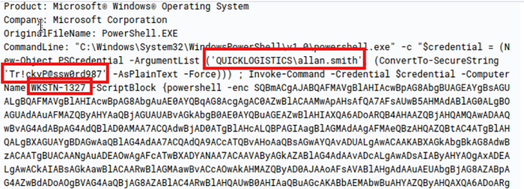
This clearly demonstrates that the threat actor utilized the compromised credentials to target and attempt remote code execution on this system.
😺11th Flag: WKSTN-1327
This host name represents the threat actor’s next point of network traversal in the compromised network.
👨‍💻12.) Using the suspicious command launched by the threat actor from the first system to move laterally, what is the parent process name of the suspicious command launched on the second compromised system?
I began by filtering for events specifically related to the aimed at system using the following query.
Open the image to view it in full size
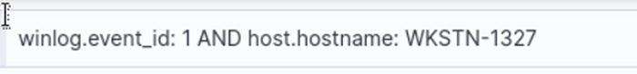
This allowed me to focus only on process creation events from the second system involved in the network traversal.
Open the image to view it in full size
This caught my attention because wsmprovhost.exe is commonly utilized by PowerShell Remoting, which aligns with network traversal activity.
😺12th Flag: wsmprovhost.exe
To confirm, I checked the parent process of this execution and found that wsmprovhost.exe was indeed the parent process utilized during the remote execution initiated from the compromised first system.
#️⃣13.) The threat actor then dumped the hashes in this second system. What is the username and hash of the newly dumped credentials? (format: username:hash)
I started by refocusing my analysis on credential extraction activity. To achieve this, I utilized the following filter.
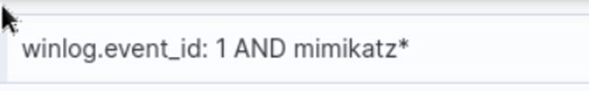
This filter is designed to capture any process execution related to Mimikatz, a known tool often utilized by attackers to extract passwords and hashes from memory.
While scanning through the results, I spotted an event that grabbed my attention. The command-line contained a reference to the user parameter and Mimikatz execution path.
Open the image to view it in full size
This strongly indicated a pass-the-hash attack using Mimikatz. I analyzed the event further by checking both the process.parent.args and process.command_line fields for verification.
Open the image to view it in full size
From the command arguments, I detected the dumped username and NTLM hash:
- Username: administrator
- Hash: 00f80f2538dcb54e7adc715c0e7091ec
😺13th Flag: administrator:00f80f2538dcb54e7adc715c0e7091ec
This clearly shows that the threat actor successfully extracted and utilized the administrator credentials to further their access.
🥟14.) After gaining access to the domain controller, the threat actor attempted to dump the hashes via a DCSync attack. Aside from the administrator account, what account did the threat actor dump?
To answer this, I began by filtering for any suspicious DCSync activity using the following search query.
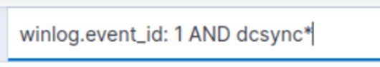
This assisted me locate potential Mimikatz-based attacks targeting domain controller synchronization.
From the filtered results, I observed an event where mimikatz.exe was launched from the path.
Open the image to view it in full size
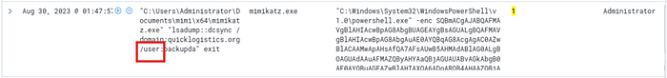
This immediately caught my attention due to the explicit /user: field, indicating a aimed at DCSync hash extraction.
I further examined the process.command_line field and verified that the threat actor had launched.
Open the image to view it in full size
This verified that in addition to the administrator account, the threat actor attempted to dump the password hash for the backupda user.
😺14th Flag: backupda
This user account was the additional target in the DCSync operation conducted using Mimikatz.
☠️15.) After dumping the hashes, the threat actor attempted to retrieve another remote file to execute ransomware. What is the link utilized by the threat actor to retrieve the ransomware binary?
To identify any attempts by the threat actor to retrieve a ransomware payload, I began by focusing on the suspicious process name I had previously noticed: ransomboogey.exe. Using this clue, I filtered the event log entries with the following query.
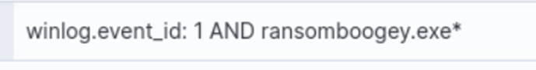
This search yielded a few events of interest. I examined each of them carefully and eventually came across a command in one of the PowerShell events that stood out. The command was using Invoke-WebRequest (iwr) to fetch a remote file.
Open the image to view it in full size
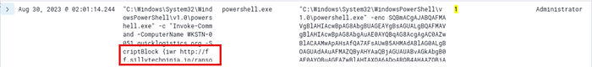
The script downloads the file and saves it locally as ransomboogey.exe in the user directory of evan.hutchinson. This strongly confirms the threat actor's intent to deploy ransomware post-credential extraction and network traversal.
Open the image to view it in full size
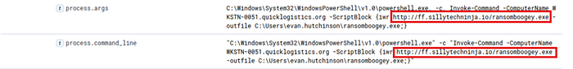
😺15th Flag: http://ff.sillytechninja.io/ransomboogey.exe
Through aimed at event filtering and process command-line analysis, I verified that the threat actor attempted to retrieve a ransomware payload named ransomboogey.exe. This was done using a PowerShell Invoke-WebRequest command to retrieve the file from the remote URL.

